Find Jobs

From the Career worklet:

1. Click **Find Jobs** under Actions.
2. View the open positions on the page or use the filters on the left to narrow your search. You can also enter keywords in the search field to find relevant positions.

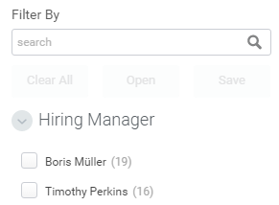

1. You can click **Clear All** to deselect all of the filters applied.
2. Click the open position you are interested in to view the Job Description. Now you can apply for the job

Apply For A Job

Once you have found a job you want to apply for:

1. Click the **Apply** button.
2. You can click **Go to Professional Profile** and make any updates you would like included in this Job Application. You will then need to navigate back to the job posting and click **Apply** again.
3. Click the **Select files** button in the Resume/Cover Letter section or drag and drop files in the designated area to attach them to your application.
4. Use the radio buttons under Internal Questions to indicate if you have spoken to your manager about applying for the position.
5. Click **Save for Later** to come back later to complete your application or click **Submit** to send your application.

|  |  |
| --- | --- |
|  | Note: Any additional edits made to your Professional Profile following the submission of your application will not be reflected on your application. Only the information and attachments present at the time of submission are included. |

View My Applications

1. From the Career worklet, click **My Applications** under View. From here, you will be able to see the date you applied for the position, the Candidate Stage you are in, and additional information about the position you applied for.